ACTIVITY - 3
Dataset Overview :
The dataset used for this analysis consists of corporate bond ratings which includes key numerical variables such as CurrentRatio , QuickRatio and CashRatio . This dataset provides synthetic scaled data related to corporate bond ratings.
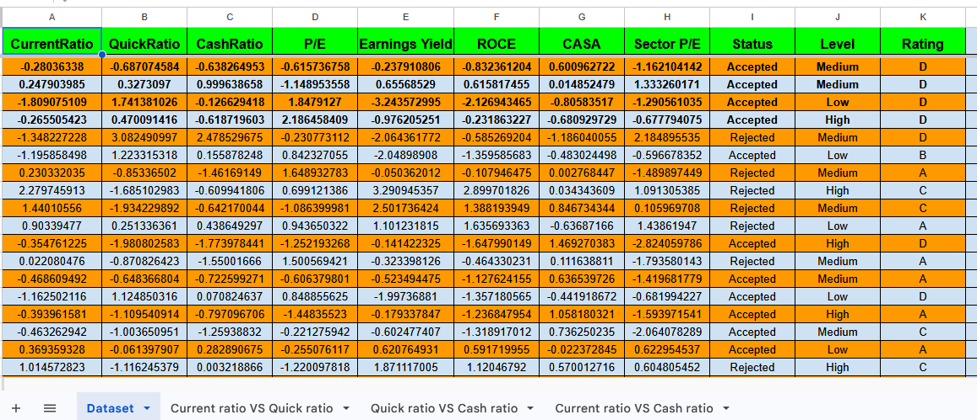
Spreadsheet Link : https://docs.google.com/spreadsheets/d/1h6O9D3sCPh5a2u3ihRe8GFwbYgQQfwVeol5003C-R_A/edit?usp=sharing

SCATTERPLOTS
For this analysis , we examine the relationships between three numerical variables
CurrentRatio , QuickRatio and CashRatio

Scatter Plot 1 : CurrentRatio vs QuickRatio
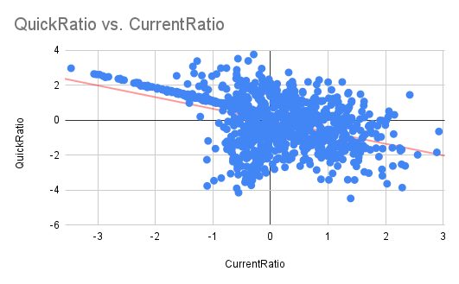
Interpretation : There is a moderate negative relationship between CurrentRatio and QuickRatio. This suggests that companies with higher current ratios tend to have lower quick ratios and vice versa .

Scatter Plot 2 : QuickRatio vs CashRatio 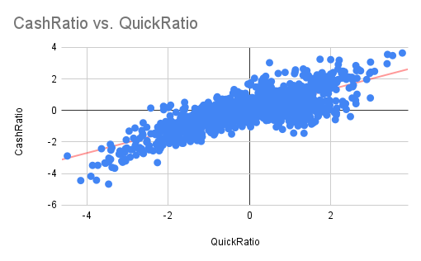
Interpretation : There is a strong positive relationship between Quick Ratio and Cash Ratio .
This implies that companies that are liquid in terms of quick assets also maintain higher cash reserves .

Scatter Plot 3 : CurrentRatio vs CashRatio
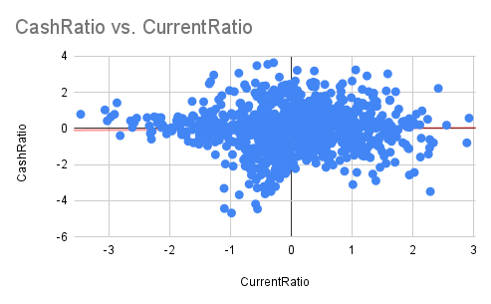

Interpretation : This is a very weak positive relationship almost negligible . It means that
Current Ratio and Cash Ratio are nearly independent and do not vary together significantly .

COVARIANCE CALCULATION
The covariance values between the selected variables are as follows :

- Cov(CurrentRatio , QuickRatio) = -0.6175027303
- Cov(QuickRatio , CashRatio ) = 1.404242774
- Cov(CurrentRatio , CashRatio) = 0.01834544702

Interpretation :
- A negative covariance between CurrentRatio and QuickRatio indicates an inverse relationship , where an increase in one variables is associated with a slight decrease in the others .

- A positive covariance between QuickRatio and CashRatio suggests that both variables move together , increasing or decreasing in tandem .

- The near - zero covariance between CurrentRatio and CashRatio indicates almost no linear relationship between these two variables .

MEAN AND STANDARD DEVIATION CALCULATION
The mean and standard deviation for the chosen variables are as follows :

- CurrentRatio :
Mean =-0.002053209172
Standard Deviation =0.9613188819
Interpretation : The Current Ratio is centered around zero (normalized) ,and its variability is moderate .this indicates that most values are not far from the average .

- QuickRatio :
Mean =-0.01279293548
Standard Deviation =1.445264062
Interpretation : The Quick Ratio has the highest standard deviation , meaning it shows the most variation among the three ratios . This indicates significant differences in quick asset liquidity across companies .
- CashRatio :
Mean =-0.02123610075
Standard Deviation = 1.226798696

Interpretation : The Cash Ratio also varies considerably , but less than Quick Ratio. It represents moderate variation in cash holdings among companies.

CHEBYSHEV’S INEQUALITY

We use chebyshev’s inequality to estimate the probability that values will lie within a certain range of the mean . For each variable, the upper and lower bounds are calculated for a deviation of 2 standard deviations from the mean.

chebyshev’s inequality provides a lower bound on the probability that a random variable
Lies within k standard deviations of the mean. The inequality states:

$ρ(|X - μ| ≥ kσ) ≤ {\frac{1}{{{k_{}^{2}}_{}^{}}^{}}}_{}$
This means that the probability that the value of X lies outside k standard deviation from the mean is at most $\frac{1}{k_{}^{2}}$ . The probability that X lies within k standard deviation from the mean is at least 1 - $\frac{1}{k_{}^{2}}$.
We’ll use k = 2 (which corresponds to 2 standard deviation) for the analysis

CurrentRatio :
- Mean ($μ$) = -0.0021
- Standard Deviation ($σ$) = 0.9313

Using k = 2
- Upper bound = $μ$ + 2 $σ$ = 1.9205
- Lower bound = $μ$ - 2 $σ$ = -1.9247

Interpretation : At least 75% of the values for the Current Ratio will lie between -1.9247 and 1.9205.

QuickRatio :
- Mean ($μ$) = -0.0128
- Standard Deviation ($σ$) = 1.4453

Using k = 2
- Upper bound = $μ$ + 2 $σ$ = 2.877
- Lower bound = $μ$ - 2 $σ$ = -2.9034

Interpretation : At least 75% of the values for the Quick Ratio will lie between -2.9034 and 2.8778.

CashRatio :
- Mean ($μ$) = -0.0212
- Standard Deviation ($σ$) = 1.2268

Using k = 2
- Upper bound = $μ$ + 2 $σ$ = 2.4324
- Lower bound = $μ$ - 2 $σ$ = -2.4748

Interpretation : Interpretation : At least 75% of the values for the Cash Ratio will lie between -2.4748 and 2.4324

